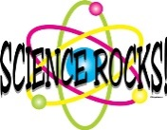 Mrs. Munsey’s Classroom News
hmunsey@gilesk12.net – 626-7281 – hmunsey@weebly.com
(Week of November 11-15, 2019)
Notes  Thanksgiving Break  (November 27,28, 29)  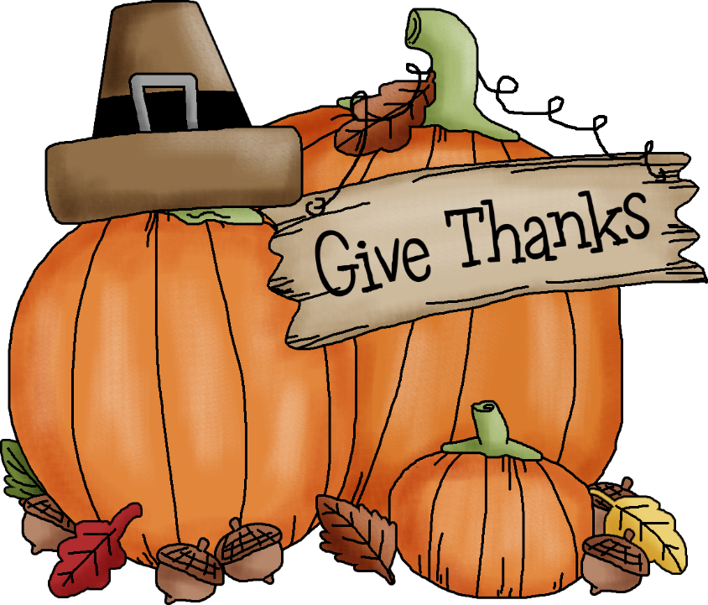  Please encourage your child to continue reading for AR (Accelerated Reader) points. | What We Are Learning  Social Studies  2.3 The student will compare the lives and  contributions of three American Indian  cultures of the past and present, with  emphasis on  a) the Powhatan of the Eastern Woodlands;  b) the Lakota of the Plains; and  c) the Pueblo peoples of the Southwest.  2.7 The student will locate and describe the  relationship between the environment and  culture of  a) the Powhatan of the Eastern Woodlands;  b) the Lakota of the Plains; and  c) the Pueblo Indians of the Southwest.
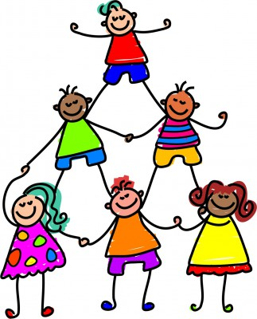 | UPCOMING EVENTS
- Tuesday – Ice cream ($0.75 or ice cream ticket)
- Friday – Popcorn ($0.50) and Fundraiser Field Trip

