Mrs. Munsey’s Classroom News
hmunsey@gilesk12.net – 626-7281 – hmunsey@weebly.com
(Week of January 27-31, 2020)
Notes  Report Cards go home on Friday, January 31.  Leah Schwartz, a student teacher from VT, joins us Wednesday through April.  Please encourage your child to continue reading for AR (Accelerated Reader) points.  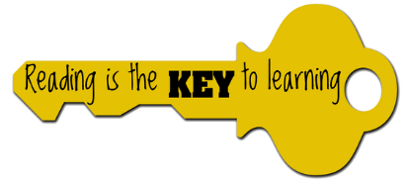 | What We Are Learning  Science SOL 2.3  States of Matter  The student will investigate and understand basic properties of solids, liquids, and gases. Key concepts include:  - Mass and Volume,  - Processes involved with changes in matter from one state to another (condensation, evaporation, melting, and freezing)
UPCOMING EVENTS
- Tuesday – Ice cream ($0.75 or ice cream ticket)
- Thursday – Matter Test – Study the back of this newsletter and the study guide going home Wednesday evening.
- Friday – Popcorn ($0.50)

