Mrs. Munsey’s Classroom News
hmunsey@gilesk12.net – 626-7281 – hmunsey@weebly.com
(Week of February 24-28, 2020)
Notes  Please encourage your child to continue reading for AR (Accelerated Reader) points.  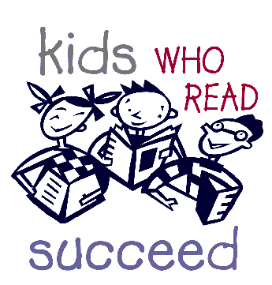 | What We Are Learning  Resources - SOL 2.8  The student will describe natural resources (water, soil, wood, and coal), human resources (people at work), and capital resources (machines, tools, and buildings).  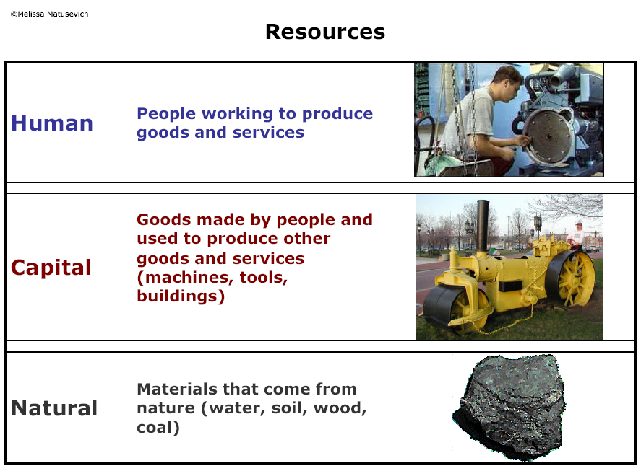
UPCOMING EVENTS
- Tuesday – Ice cream ($0.75 or ice cream ticket)
- Tuesday – Life Cycles Test
- Friday – Popcorn ($0.50)

