Mrs. Munsey’s Classroom News
hmunsey@gilesk12.net – 626-7281 – hmunsey@weebly.com
(Week of March 9 - 13, 2020)
Notes  Please encourage your child to continue reading for AR (Accelerated Reader) points. | What We Are Learning  VA Plant Resources - SOL 2.8  The student investigate and understand that plants are important natural resources.  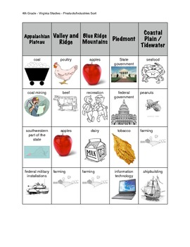
UPCOMING EVENTS
- Tuesday – Ice cream ($0.75 or ice cream ticket)
- Tuesday – Economics Test (History SOLs 2.8-2.10)
- Friday – Popcorn ($0.50)

