Mrs. Munsey’s Classroom News
hmunsey@gilesk12.net – 626-7281 – hmunsey@weebly.com
(Week of August 26 – 30, 2019)
Notes | What We Are Learning  - We are learning our Bus Safety Rules. (Quiz Thursday – Study guide on the back.)  - We are learning to be a good citizen by following our school and classroom rules. (SOL 2.10)  - We are also learning about each other.
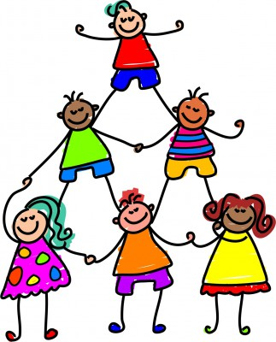  - Please complete and return all student information paperwork.  - Please check your child’s homework folder every evening. | UPCOMING EVENTS  - Tuesday – Ice cream  - ($0.75 or ice cream ticket)  - Thursday – Bus Safety Quiz  - Friday (8/30) – NO SCHOOL  - Monday (9/2) – NO SCHOOL  - Next Week - We will be learning the steps of The Scientific Method

