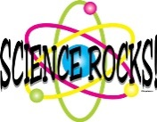 Mrs. Munsey’s Classroom News
hmunsey@gilesk12.net – 626-7281 – hmunsey@weebly.com
(Week of September 2-6, 2019)
Notes  - Please complete and return all student information paperwork.  - Please check your child’s homework folder every evening.  - Fall Pictures – Friday, September 27 | What We Are Learning  - We are learning our library rules and our dress code.  - We are learning to think like a scientist by following the Scientific Method. (Science SOL 2.1)  - Ask a question.  - Make a hypothesis (guess).  - Conduct and experiment (test).  - Collect and record data (information).  - Analyze and draw conclusions.  - Report results.
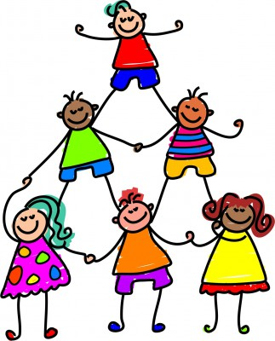 | UPCOMING EVENTS  - Tuesday – Ice cream ($0.75 or ice cream ticket)  - Friday – A classwork grade will be taken for our group activities with the scientific method.  - Friday – Popcorn (free this week)

