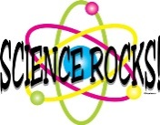 Mrs. Munsey’s Classroom News
hmunsey@gilesk12.net – 626-7281 – hmunsey@weebly.com
(Week of December 4-8, 2017)
Notes  - Please encourage your child to continue reading for AR (Accelerated Reader) points. | What We Are Learning  History SOL 2.2  The student will compare the lives and contributions of three American Indian cultures of the past and present, with emphasis on the Powhatan of the Eastern Woodlands, the Lakota of the Plains, and the Pueblo peoples of the Southwest.  History SOL 2.4  c) locating the regions of the Powhatan, Lakota, and Pueblo Indians on United States maps;  d) understanding the relationship between the environment and the culture of the Powhatan, Lakota, and Pueblo Indians.
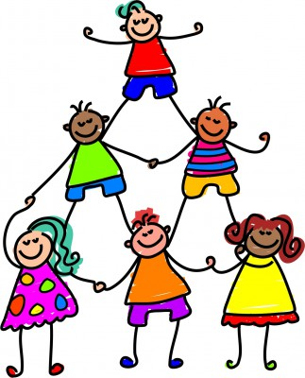 | UPCOMING EVENTS  - Tuesday – Ice cream ($0.75 or ice cream ticket)  - Thursday – Lakota Quiz  - Friday – popcorn ($0.25)

