Mrs. Munsey’s Classroom News
hmunsey@gilesk12.net – 626-7281 – hmunsey@weebly.com
(Week of February 17-21, 2020)
Notes  Please encourage your child to continue reading for AR (Accelerated Reader) points.  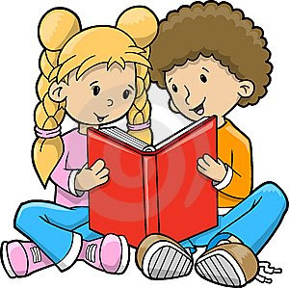 | What We Are Learning  Science SOL 2.4  Life Cycles  The student will investigate and understand that plants and animals undergo a series of orderly changes as they mature and grow. Key concepts include:  a) animal life cycles; and  b) plant life cycles  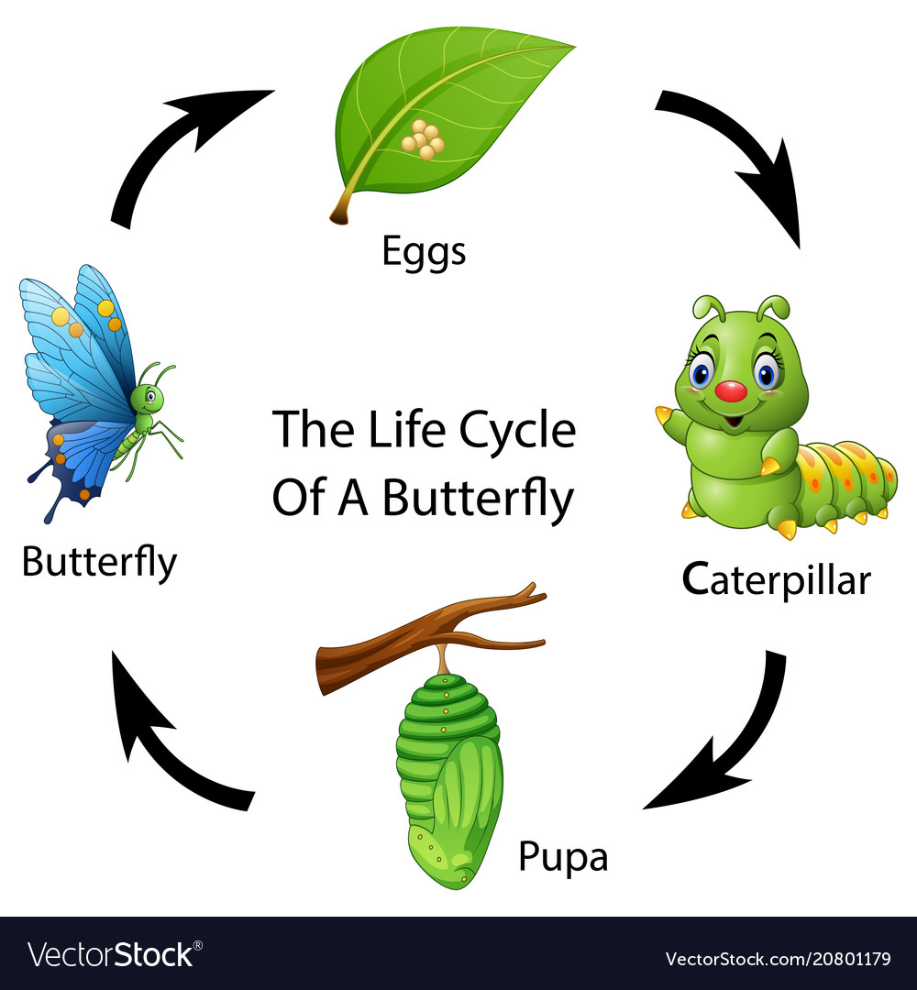
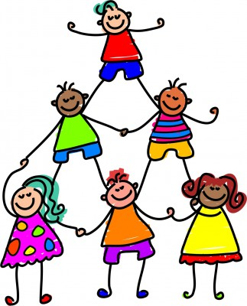 | UPCOMING EVENTS  - Tuesday – Ice cream ($0.75 or ice cream ticket)  - Friday – Popcorn ($0.50)  - Test – Tuesday 2/25

