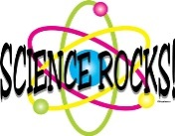 Mrs. Munsey’s Classroom News 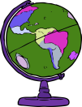
hmunsey@gilesk12.net – 626-7281 – hmunsey@weebly.com
(Week of September 16-20, 2019)
Notes  - September 27: Fall Picture Day  - October 4 – Fundraiser ends  - Please encourage your child to continue reading for AR | What We Are Learning  History SOL 2.6  The student will develop Map skills by using globes and maps of the world and the United States to locate:  - The seven continents and five oceans  - The equator, the Prime Meridian and the four hemispheres; and  - Major rivers, mountain ranges, lakes, and other physical features in the United States.
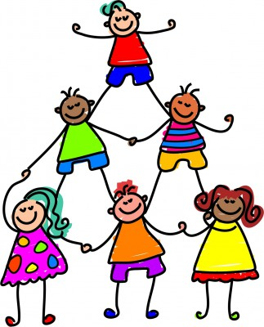 | UPCOMING EVENTS  - Tuesday – Ice cream ($0.75 or ice cream ticket)  - Friday – Popcorn ($0.50)  - Tuesday (10/1) – Maps and Globes Test

