Mrs. Munsey’s Classroom News
hmunsey@gilesk12.net – 626-7281 – hmunsey@weebly.com
(Week of March 2, 2020)
Notes  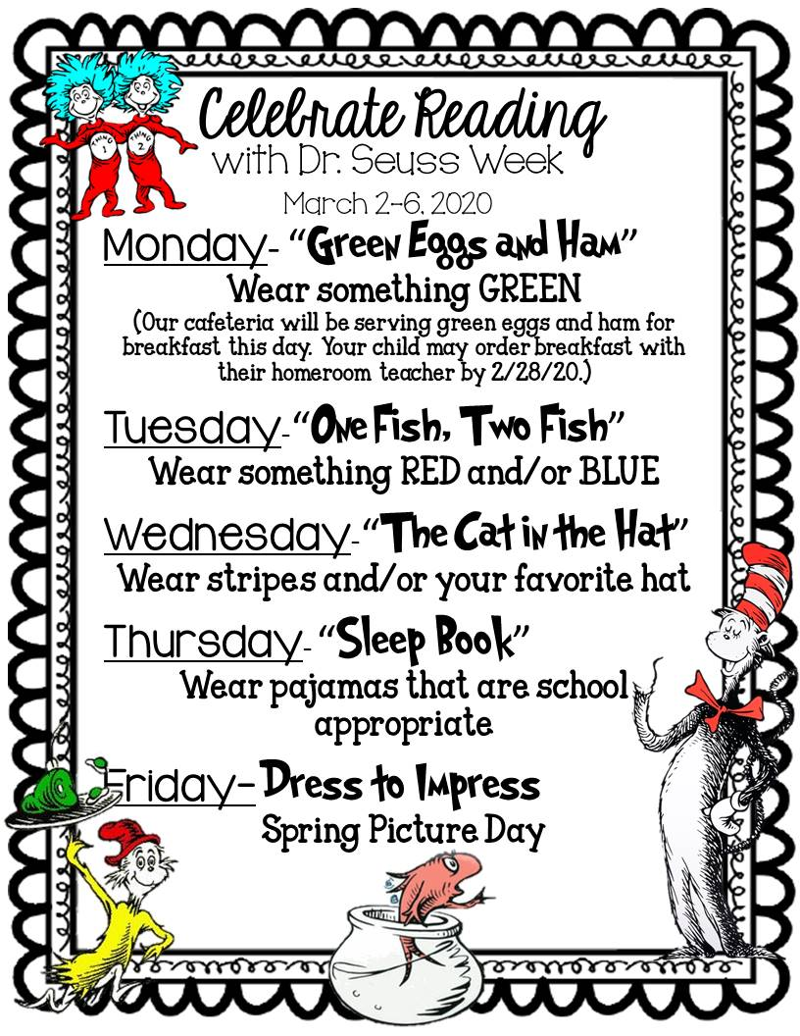 | What We Are Learning  Resources - SOL 2.8  The student will describe natural resources (water, soil, wood, and coal), human resources (people at work), and capital resources (machines, tools, and buildings).  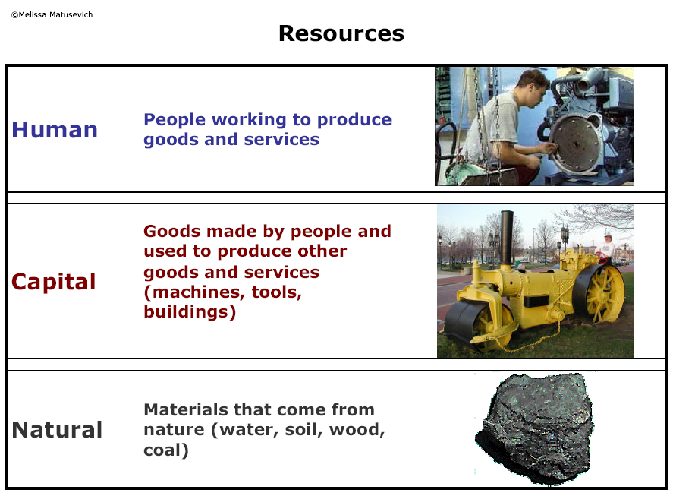
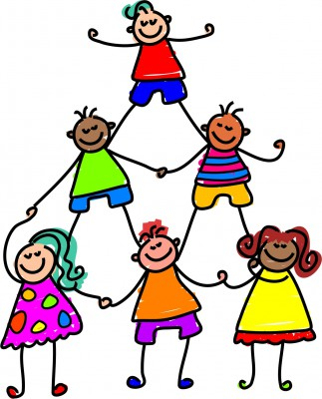 | UPCOMING EVENTS  - Tuesday – Ice cream ($0.75 or ice cream ticket)  - Wednesday – Resources Quiz  - Friday – Class Pictures and Popcorn ($0.50)

